Quality of Service Analysis
Norbert Doerry
August 8, 2026
- Introduction
Quality of Service (QOS) is a reliability metric for the shipboard electrical power system as experienced by individual loads. QOS is defined in IEEE Std 45.1 and IEEE Std 45.3. Its associated metric is a mean time between service interruption (MTBSI) where a service interruption is an electrical power system disruption of a duration that exceeds the capability of the load to continue to fulfill its function. Different types of loads tolerate different levels of service disruption durations. The duration of a service disruption that a load can tolerate is evaluated against two times durations: Reconfiguration time (t1) and Generator start time (t2). Based on the comparison of the service disruption duration with t1 and t2, each load can be assigned to one of three QOS categories: uninterruptible, short-term interrupt, and long-term interrupt. An additional subcategory of long-term interrupt is defined as exempt load which is used to determine the amount of redundancy provided by the generator sets.
Power system design should provide all uninterruptible loads with uninterruptible power; typically, this is implemented with an uninterruptible power supply (UPS). This UPS should fulfill ESM-F1 functionality, and possibly fulfill ESM-F2 functionality. The power system should be operated such that the loss of one online generator set will enable powering all uninterruptible loads and short-term interrupt loads with the remaining online generator sets and available energy storage fulfilling ESM-F2 functionality. The power system should be capable of restoring all but a portion of the exempt loads within t2 seconds following the start of the power disruption.
The customer establishes the requirement for MTBSI for each load. A customer may elect to not apply QOS to non-critical (non-vital) loads; essentially treating all non-critical loads as exempt loads. For other loads, a MTBSI requirement of 30,000 hours is not unreasonable.
QOS analysis evaluates whether the MTBSI requirement is met for each load. The steps for performing a QOS analysis are:
  - Establish MTBSI requirement
  - Determine t1 and t2
  - Categorize loads
  - Determine reliability of power system equipment
  - Estimating MTBSI for loads
This document is based in part on Doerry (2007), Doerry and Amy (2011), and IEEE Std. 45.3.
- Definitions
  - Service Disruption
Although not defined in any standard, this document defines a service disruption to occur whenever power quality is outside of its normal steady-state values. Service disruptions may occur for a variety of reasons including:
- Fault within user equipment causing voltage to fall below its minimum value before the applicable circuit breaker trips.
- Generator sets tripping off line
- Power distribution equipment failures
  - Service Disruption Duration
Although not defined in any standard, this document defines service disruption duration to be the amount of time power quality is outside of its normal steady-state values for a given service disruption.
  - Service Interruption
From IEEE Std. 45.1: “A service interruption is any interruption in service or power quality degradation outside of acceptable parameters for a period of time that results in the load’s parent system not being capable of meeting its requirements.”
  - Reconfiguration time (t1)
From IEEE Std 45.1: “Reconfiguration time (t1) is defined as the maximum time to reconfigure the distribution system without bringing on additional generation capacity.”
  - Generator start time (t2)
From IEEE Std 45.1: “Generator start time (t2) is defined as the maximum time to bring the slowest power generation module online.”
  - Mean time between service interruptions (MTBSI)
For a given electrical load, the MTBSI is the average (mean) time between the occurrences of service interruptions for that load over the ship’s service life.
  - Uninterruptible Load
Uninterruptible loads cannot tolerate service disruption durations of t1 or greater. Service disruptions of duration t1 or greater are service interruptions for a particular uninterruptible load.
  - Short-term interrupt load
A short-term interrupt load tolerates service disruption durations of t1 or less and cannot tolerate service disruption durations of t2 or greater. Service disruptions of duration t2 or greater are service interruptions for a particular load. Service disruptions of duration between t1 and t2 may, or may not be service interruptions. The power system should be designed to prevent short-term interrupt loads from experiencing power disruptions longer than t1.
  - Long-term interrupt load
A long-term interrupt load tolerates service disruption durations of t2 or less. The power system should be designed to prevent long-term interrupt loads (except possibly exempt loads) from experiencing power disruptions longer than t2.
  - Exempt load
From IEEE Std 45.1: “Exempt loads are a special case of long-term interrupt loads that do not require restoration within t2, which are common on complex vessels such as naval combatants.”
- QOS strategies
A ship designer has considerable flexibility in meeting QOS requirements:
  - Load shedding
Should an online generator set trip offline, the remaining generator set capacity is unlikely to be sufficient to serve all loads. As depicted in Figure 1, one strategy to avoid service interruptions is to initially shed all long-term interrupt loads; start and bring online the standby generator; and restore all loads before time t2 has elapsed. Assuming sufficient load has been shed such that the remaining generator set capacity is enough to serve all remaining loads, no loads will have experienced a service interruption.
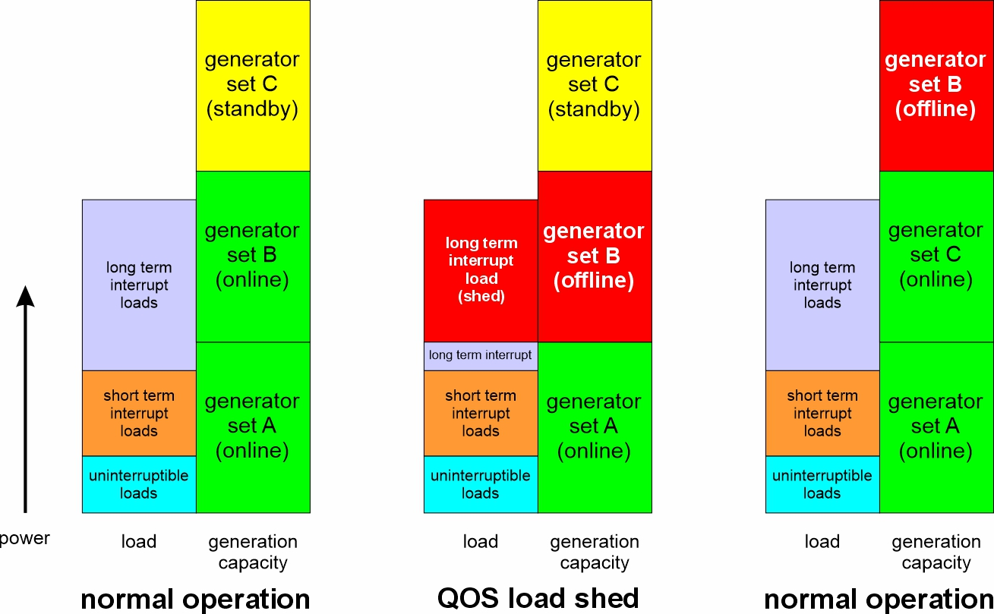
Figure 1: QOS load shedding

  - Energy storage
In Figure 1, after one generator set tripped offline, the remaining generator set had sufficient capacity to serve all the uninterruptible and short-term interrupt loads. In Figure 2, upon a generator set tripping offline, the remaining generator set does not have sufficient capacity by itself to serve all the uninterruptible and short-term interrupt loads. In this case, energy storage (fulfilling ESM-F2 functionality) is employed with the remaining generator set to power all uninterruptible and short-term interrupt loads (and possibly some long-term interrupt loads) until the standby generator set is brought online.
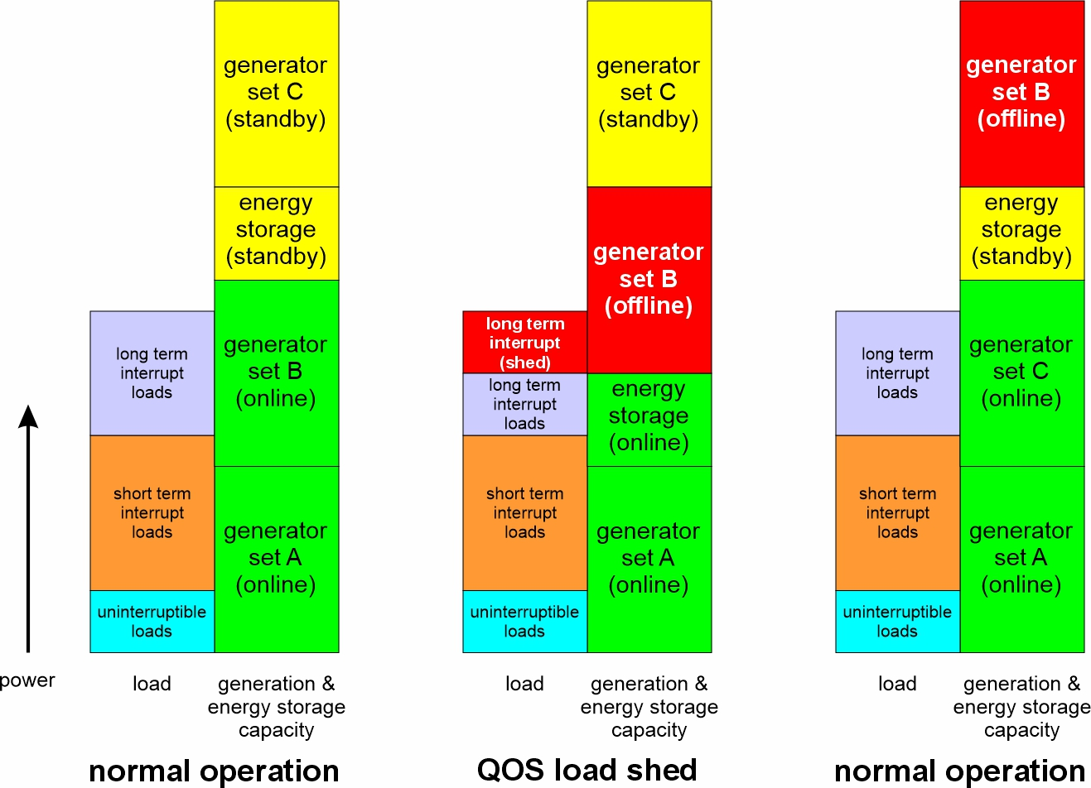
Figure 2: QOS load shedding with energy storage
Energy storage in the form of a UPS (fulfilling ESM-F1 functionality) is also typically used to power uninterruptible loads. Generally, the number of loads powered by a single UPS should be limited to avoid service interruptions caused by failures in other loads. The UPS should have a mean time between failure (MTBF) much greater than the MTBSI requirement. In the definition of MTBF, a failure should be defined as one that could potentially result in a service interruption to served loads.
  - Redundant sources with automatic bus transfers (ABT)
If the power system is operated in split plant, then a service interruption may be avoided by supplying specific loads with an ABT (example shown in Figure 3) that automatically switches to another source of power upon loss of the primary source of power.
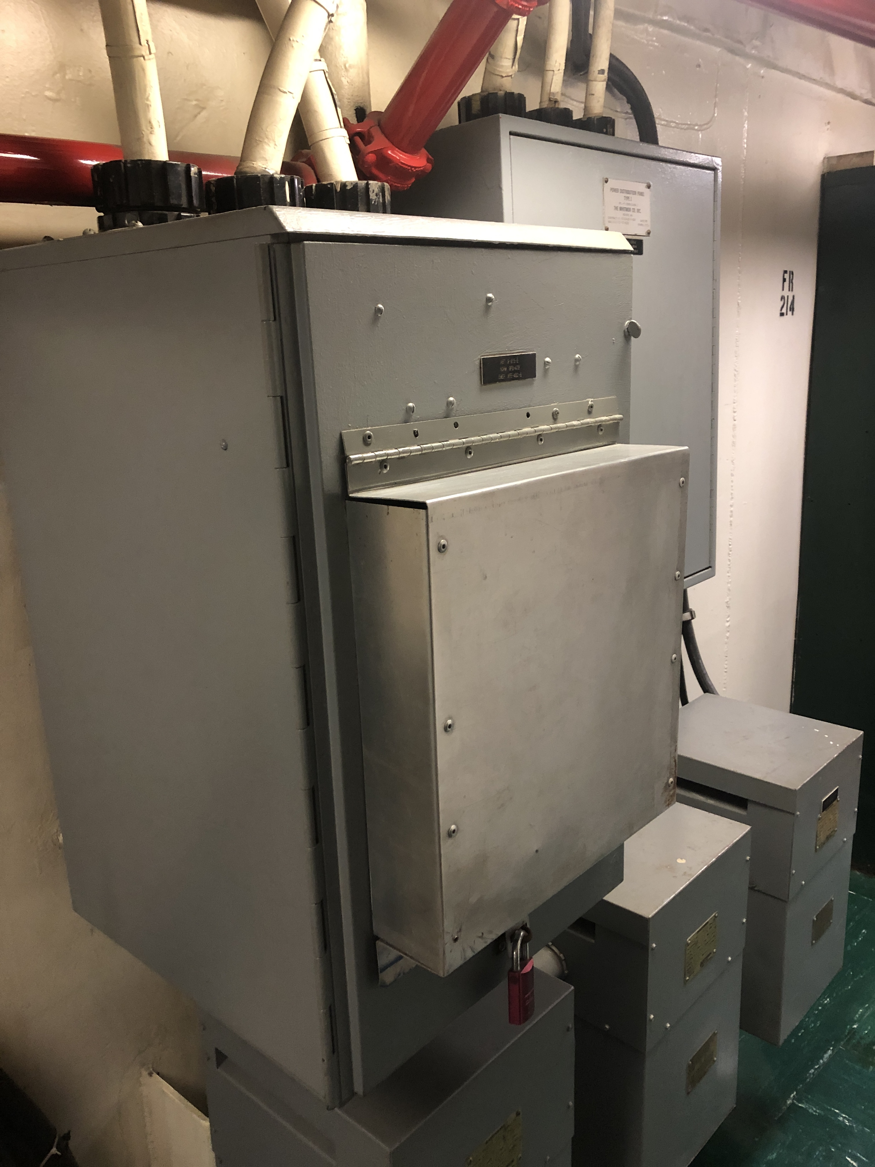
Figure 3: Automatic Bus Transfer (© 2022 by Norbert Doerry)
  - Reliable power system equipment
Any non-redundant power system equipment / components that could be a single source of failure should have a MTBF significantly greater than the required MTBSI. Examples of non-redundant power system equipment / components include:
- Cable
- Circuit breakers
- Load centers / power panels
- Automatic bus transfers
With proper equipment / component specifications, effective acquisitions, good installation practices and good maintenance practices, all of these equipment / components should have sufficient MTBFs. Overloading components, providing insufficient cooling, improper installation or a lack of maintenance may result in not meeting QOS MTBSI requirements.
  - Generator set ratings
One may avoid providing energy storage with functionality ESM-F2 if generator set ratings are chosen such that under any operating condition, the amount of long-term interrupt load exceeds the rating of the largest online generator set. This soft constraint tends to drive the use of more, smaller, generator sets and may be in conflict with energy efficiency goals and reducing machinery room volume. The ratings of the generator sets and the amount of energy storage becomes an optimization problem during the design process.
  - Power conversion equipment modularity
Procuring non-modular power electronic conversion equipment with the requisite power quality to achieve MTBSI requirements may prove challenging. One alternative is to provide redundant converters and employing ABTs to switch between the converters when the normal source fails. This approach however, may prove to be costly.
Another approach is to use power electronic converters that are inherently modular, where the power modules may be paralleled and hot-swapped. The power modules should have a rating such that two or three of them are needed to meet the load; an additional module is provided (N+1) to ensure sufficient capacity for supplying the load with one module out of service. Hot swapping allows the operator to remove and replace the out of service module without impacting the loads.
  - Grounding system selection
Ungrounded and high resistance ground (HRG) power systems are largely not impacted by line-to-ground faults; the line-to-line voltages experience only small disturbances that are likely within steady-state tolerances. The line-to-ground faults can be cleared when convenient to do so. In solid grounded power systems, high currents flow during a ground fault; these high currents can impact power quality until the fault clears (either on its own or via fault protection devices.) In some cases, the power quality can degrade enough for a sufficient amount of time to result in a service-interruption.
Power distribution systems serving critical and emergency equipment should be either ungrounded or HRG systems to avoid the potential power quality issues with solid grounded systems. Power distribution systems serving only non-critical loads should consider employing solidly grounded systems in order to quickly detect and clear line to ground faults.
- QOS Analysis Process
  - Establish MTBSI requirement
IEEE Std 45.3 recommends establishing a MTBSI of between 10,000 and 30,000 hours. Critical non-redundant loads should generally have a larger MTBSI, while critical loads may have a lower MTBSI. Non-critical loads may not have a MTBI assigned to them.
  - Determine t1 and t2
During a fault, the voltage at the terminals of a load may be outside of power quality limits for a period of time until circuit breakers or protective devices clear the fault. T1 is the maximum time such a fault can exist before the fault is cleared and power quality is restored. For conventional circuit breakers, assuming a value between 0.5 s and 2 s for t1 is usually acceptable. If solid state circuit breakers are used, then t1 times on the order of 1 to 100 milliseconds may be appropriate.
Generator start time (t2) depends on the characteristics of the prime mover; values between 45 seconds and 5 minutes are reasonable; diesel generator sets tend to have lower values for t2, while twin-spool gas turbine generator sets tend to have higher values for t2.
  - Categorize loads
Based on each load’s tolerance to a power disruption and the definitions of t1 and t2, the QOS category is determined by each load. Some general guidance:
- Loads with thermal inertia, such as freezers, refrigerators, HVAC electric heaters, and water heaters should be long term interrupt loads.
- Non-critical loads should be long-term interrupt loads.
- Power reserved for electric propulsion operation above a defined minimum speed should be long-term interrupt loads and also designated as exempt load.
- Power reserved for electric propulsion operation to achieve a defined minimum speed should be designated as a short-term interrupt load
- Unless required by regulation to be uninterruptible, emergency lighting should be a short-term interrupt load. Other lighting should be long-term interrupt load
- Most motors (and motor controllers) other than non-critical loads, should be short-term interrupt loads.
- Computer systems should be studied (and possibly tested) to determine the duration of a service disruption that leads to a service interruption. The QOS category should then be determined by comparing this duration to t1 and t2.
  - Determine reliability of power system equipment
Generally, the least reliable power system equipment in a shipboard power system are generator sets and power electronic converters. If the power system is operated with sufficient online generator and energy storage capacity and redundancy, and with an effective load shedding strategy, then the loss of a generator set or power electronic converter module is not likely to result in a service interruption. Hence one needs only a very rough estimate of the Mean Time Between Failure (MTBF) and the Mean Time To Repair (MTTR) to conclude that the loss of a generator or power electronic converter module will not impact a MTBSI calculation.
On the other hand, the reliability of single-points-of failure, such as cable, circuit breakers, load centers, power panels, and automatic bus transfers may directly impact the MTBSI. Accurately estimating the MTBF and MTTR of circuit breakers and automatic bus transfers may prove to be very important.
  - Estimating MTBSI for loads
The MTBSI is estimated by:
- For each operational condition and ambient condition, identify the loads that would suffer a service interruption upon loss of each power system equipment or component individually. The failure could be due to a loss of power connectivity between the source and the load, or could be due to the lack of surviving capacity to serve the load, even after load shedding. In determining whether a service interruption occurs due to a loss of a generator set, one assumes that a standby generator set, if available, comes online within time t2; and exempt loads are shed.
- The failure rate (F_{i}) for each power system equipment, component i, is given by:
$$F_{i}=\frac{1}{{MTBF}_{i}}$$
The ${MTBF}_{i}$ should be based on calendar time (not purely operational time) and should take into account the percentage of time the equipment or component is operational.
The MTBSI for each load is given by:
$$MTBSI= \frac{1}{\sum_{j=1}^{M}{\sum_{i=1}^{N}{F_{i}}p_{j}s_{ij}}}$$
Where:
N = number of power system components
M = total number of combinations of operational conditions and ambient conditions
p_{j} = fraction of time ship operates in each combination of operational conditions and ambient conditions
s_{ij} = 1 if a service interruption occurs due to a failure of component i in the operational condition and ambient condition j; = 0 otherwise. If a load is not operational during the combination of operational condition and ambient condition, then s_{ij} = 0.
If particular loads have failure modes that can result in service interruptions to other loads, and the MTBF for that failure mode is not significantly higher than the MTBSI requirement, then the load should be included in the set of power system components used in the calculations.
A steady-state simulation or a quasi-steady state simulation may be required to determine s_{ij}. In many cases however, s_{ij} may be determined by inspection.
These calculations assume that the MTTR for power system equipment and components are small enough that the probably of simultaneous failure of more than one equipment or component is small. If this assumption is not the case, then the analysis may be modified to include the cases of simultaneous failure.
- References
IEEE Std 45.1 IEEE Recommended Practice for Electrical Installations on Shipboard--Design
IEEE Std 45.3 IEEE Recommended Practice for Electrical Installations on Shipboard--Systems Engineering
Doerry, CAPT Norbert, "Designing Electrical Power Systems for Survivability and Quality of Service" presented at ASNE DAY 2007, Arlington, VA, June 25-26, 2007.
Also published in ASNE Naval Engineers Journal, 2007, Vol. 119 No 2, pp 25-34.
Doerry, Norbert, and John Amy, "Implementing Quality of Service in Shipboard Power System Design" presented at IEEE ESTS 2011 Alexandria VA

